We are students and researchers at Harvard University Graduate School of Design, and we created this survey as part of a project to help us find out which places Somerville could improve to make it easier and safer for kids to walk and bike to school.  
  
We are also trying to find out how people choose which route they will take to walk or bike to school.  
  
You can help us with our project by answering the questions in this survey. We think it will take you less than 10 minutes to answer all the questions. To thank you for taking the survey, we can send you or your caregivers a $10 Amazon gift card when you are done.  
  
A risk is something bad that can happen to you. Taking this survey might have a risk that you remember something bad or scary about getting to school. You do not have to answer any questions you do not want to.  
  
A benefit is something good that can happen to you. There are no benefits from taking this survey, but we hope that your answers might help us think of ways to make streets safer and better for other kids.  
  
If you or your caregivers have any questions about this survey, you or they can email Carole Voulgaris at [cvoulgaris@gsd.harvard.edu](mailto:cvoulgaris@gsd.harvard.edu)

Which of these best describes you?

* I am a student taking this survey by myself
* I am a student taking this survey together with my caregiver
* I am a caregiver taking this survey on behalf of a student in my care (in this case, answer all questions as if you were the student)

Which school do you attend?

* Winter Hill School (at Edgerly)
* Winter Hill School (at Capuano)
* Benjamin G. Brown School
* Other _________________

What grade are you in?

* Pre-K
* Kindergarten
* 1st grade
* 2nd grade
* 3rd grade
* 4th grade
* 5th grade
* 6th grade
* 7th grade
* 8th grade

What pronouns do you use?

* She/her
* He/him
* They/them
* Other_________________

Draw an X on a spot at or near where you live.

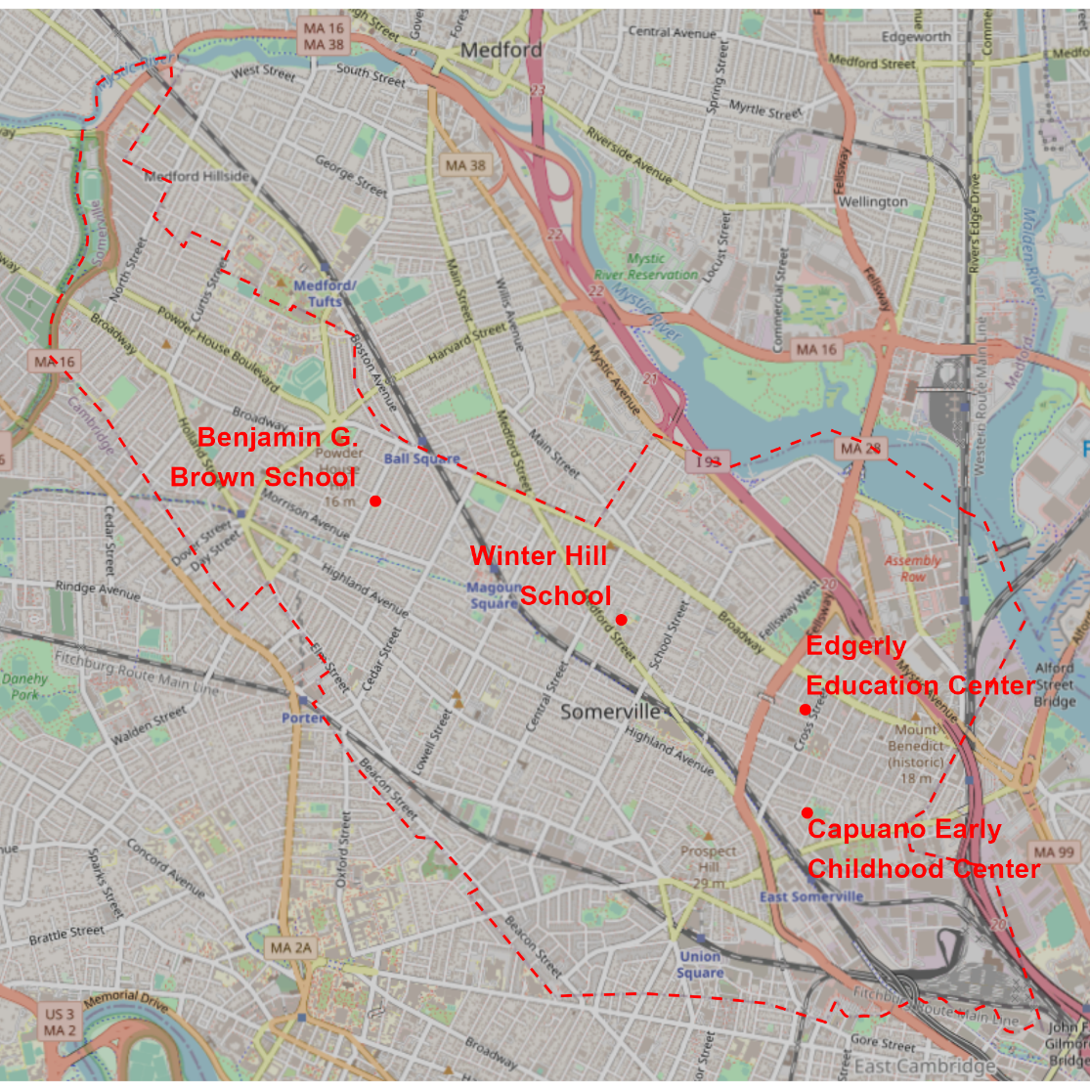

Who do you usually travel to school with? You can choose more than one answer.

* By myself
* With an adult I live with
* With an adult I do not live with
* With a kid I live with
* With a kid I do not live with

What is the main way you get to school most mornings?

* In a car (go to page 4)
* On a bike (skip to page 8)
* Walking (including a wheelchair or other mobility device) (skip to page 8)
* On an MBTA bus or train (skip to page 7)
* On a school bus (skip to page 5)

What is the main reason you do not usually walk to school?

* It is not safe.
* It would take too long.
* There is no one to walk with me.
* Other ________________________________

What is the main reason you do not usually bike to school?

* I do not have a bike.
* I do not know how to ride a bike.
* It is not safe.
* It would take too long.
* There is no one to walk with me.
* Other ________________________________

Skip to page 12.

Where does the school bus pick you up in the morning?

* At Winter Hill School (115 Sycamore Street) (go to page 6)
* At or near my home (skip to page 7)
* Another location (skip to page 7)

For the rest of this survey, “school” means the Winter Hill School at 115 Sycamore Street, where the bus picks you up.

How do you usually get to school (the Winter Hill School at 115 Sycamore Street) in the morning?

* In a car (go to page 4)
* On a bike (go to page 8)
* Walking (including with a wheelchair or other mobility device) (go to page 8)
* On an MBTA bus or train (go to page 7)

Draw an X on the spots at or near where you get on and off the bus or train. If you take more than one bus or train, show where you got on the first one and where you get off the last one.

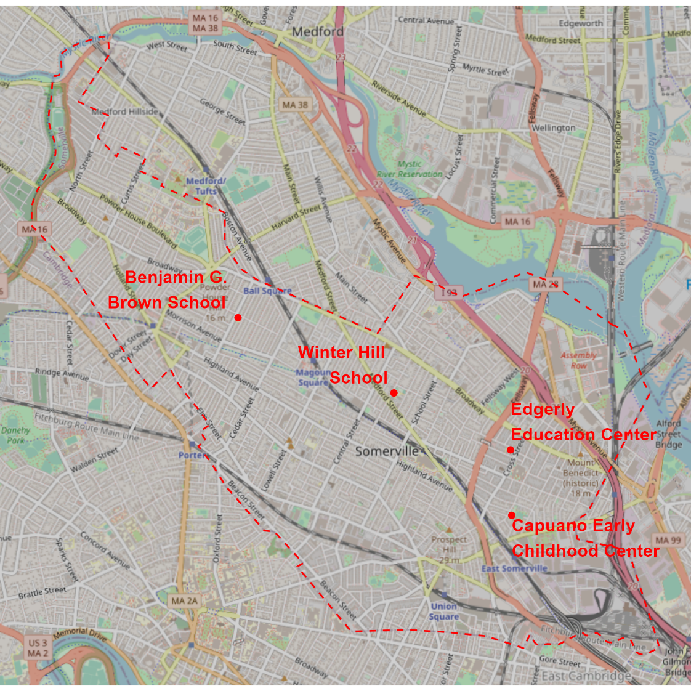

Skip to page 10.

When you go to school in the morning, do you usually go straight to school, or do you stop somewhere else first?

* I go straight to school (go to page 10)
* I stop somewhere in Somerville first (go to page 8)
* I stop somewhere outside of Somerville first (go to page 9)

What is the reason for making a stop on your way to school?

* To drop someone off at their work, school, or daycare
* To meet someone who takes me to school or travels to school with me
* Something else ____________________

Draw an X on a spot at or near the last place you stop on the way to school.

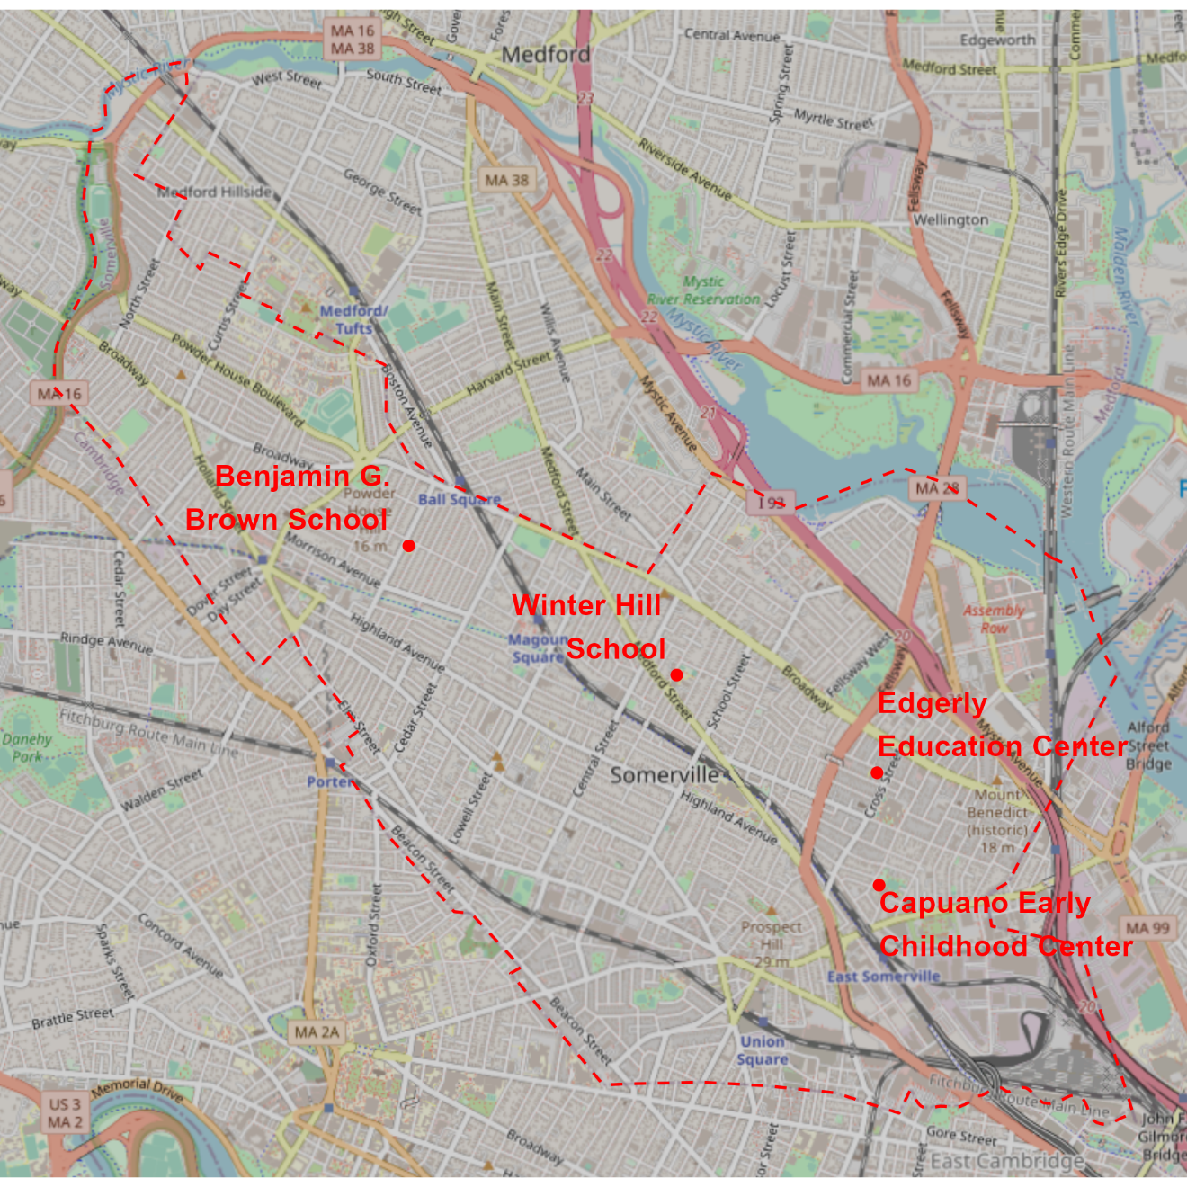

What is the reason for making a stop on your way to school?

* To drop someone off at their work, school, or daycare
* To meet someone who takes me to school or travels to school with me
* Something else ____________________

Draw an X on a spot on the Somerville boundary (the red dashed line) that you pass by on your way to school after making a stop outside of Somerville.



Draw the route you usually take to walk or bike to school (from home, an MBTA bus stop, or the last stop you make on the way to school).



Is this the shortest (most direct) route you could take to school?

* This is the shortest route I could take (go to page 13)
* There are other routes I could take that are about the same distance, but I prefer this one (go to page 12)
* There are shorter routes I could take, but I go out of my way to take this one (go to page 12)

Why do you prefer your route over others that are the same distance or shorter (you can choose more than one answer)?

* It avoids places that are unsafe because of traffic
* It avoids places that are unsafe for other reasons
* It avoids locations with bad sidewalks
* There are more interesting things to see along the way
* It is more separate from traffic
* Other _________________________

Draw the shortest route you could take to walk or bike to school (from home, an MBTA bus stop, or the last stop you make on the way to school).



Circle up to five places you would pass along the shortest possible route to school that are worse that the places you walk through on the route you actually take to school.



What is bad about these places?

___________________________________________________________________________________________________________________________________________________________________________________________________________________________________________________________________________________________________________________________________________________________________________________________________

Circle up to five places along your route to school that you like walking past or through.



What do you like about these places?

___________________________________________________________________________________________________________________________________________________________________________________________________________________________________________________________________________________________________________________________________________________________________________________________________

Circle up to five places along your route to school that you dislike walking past our through.



What do you dislike about these places?

___________________________________________________________________________________________________________________________________________________________________________________________________________________________________________________________________________________________________________________________________________________________________________________________________

Thank you for taking this survey!

We would like to send you a $10 Amazon gift card to thank you for your time. Please write the email address we should send it to:

__________________________________________________________________________